

**Faculty of engineering - Shoubra**

**Benha University**

|  |  |  |  |
| --- | --- | --- | --- |
|  | Name | Edu mail | B.N |
| 1 | **حسام ابراهيم محمد احمد ضليفي** | Hossam195310@feng.bu.edu.eg | **280** |

**TOBIC: Programming languages**

* **Application Brief:**

This application talking about programming languages ​​which used to communicate with a computer and give it a set of tasks to do, and there are list of programming languages ​​such as C and C ++ which are considered middle-level programming languages. Despite the abstraction that is done to the code for it to remain understandable and easy to use for programmers, this has little to no cost when it comes to performance and efficiency which high-level programming languages ​​affects greatly. We can say programming language is the language of the future because it has a lot of uses which helps us in our life.

* **Screen shots:**

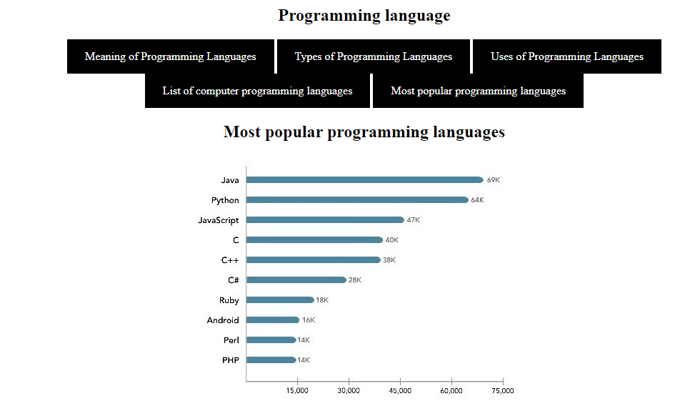

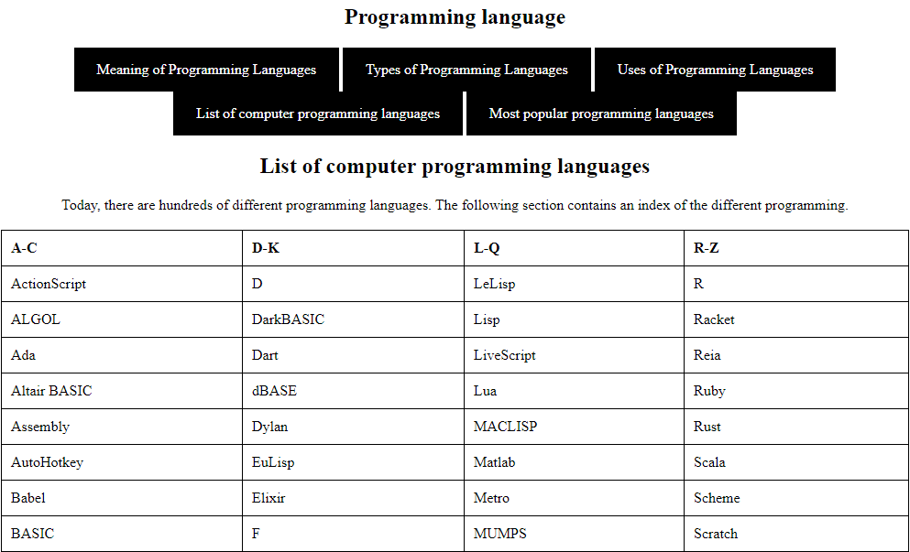

* **Source code:**

